REVIEWING AND SUBMITTING YOUR TIMESHEET VIA MOBILE APP

All employees are responsible for reviewing their weekly timesheet for accuracy and then submitting it for supervisor approval.

Sign into the app using your WTPS login.

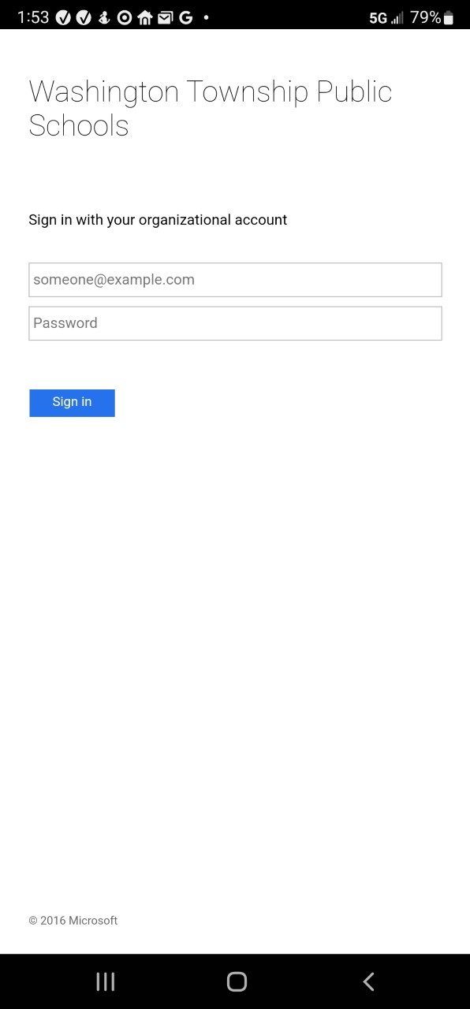

Click on the My Account tile.



Click on My Current Timesheet.

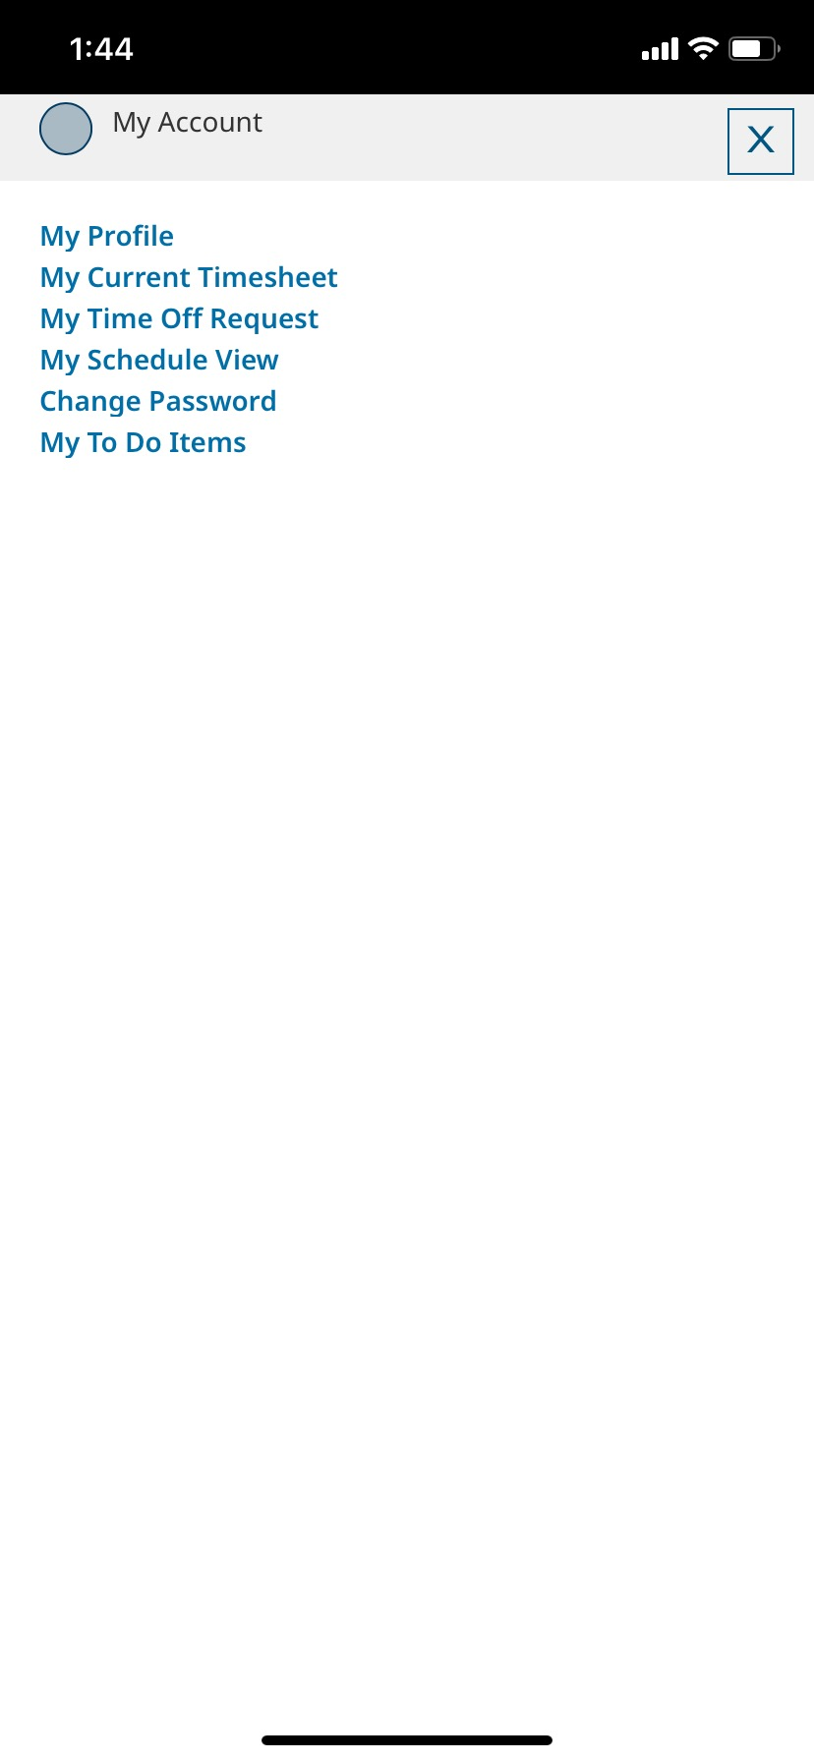v

Your timesheet should be similar to this. The days will be pre-populated based on your work schedule.

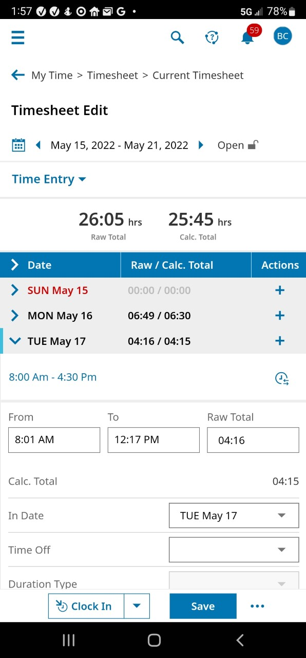

Your scheduled work times are shown here. If this is incorrect, please contact Payroll at [payroll@wtps.org](mailto:payroll@wtps.org)



Click on the carat next to each date to review your time clocked in/out for that day. Scroll down as the times will be broken down based on each time you clocked in and out.

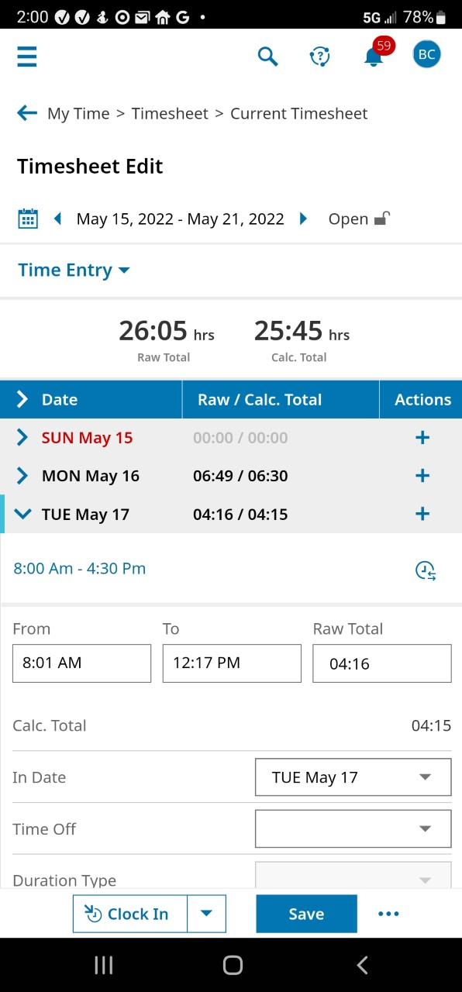

How your time is logged is shown under Activities. The default is Reg Schedule. These are for your regularly scheduled work hours each day.

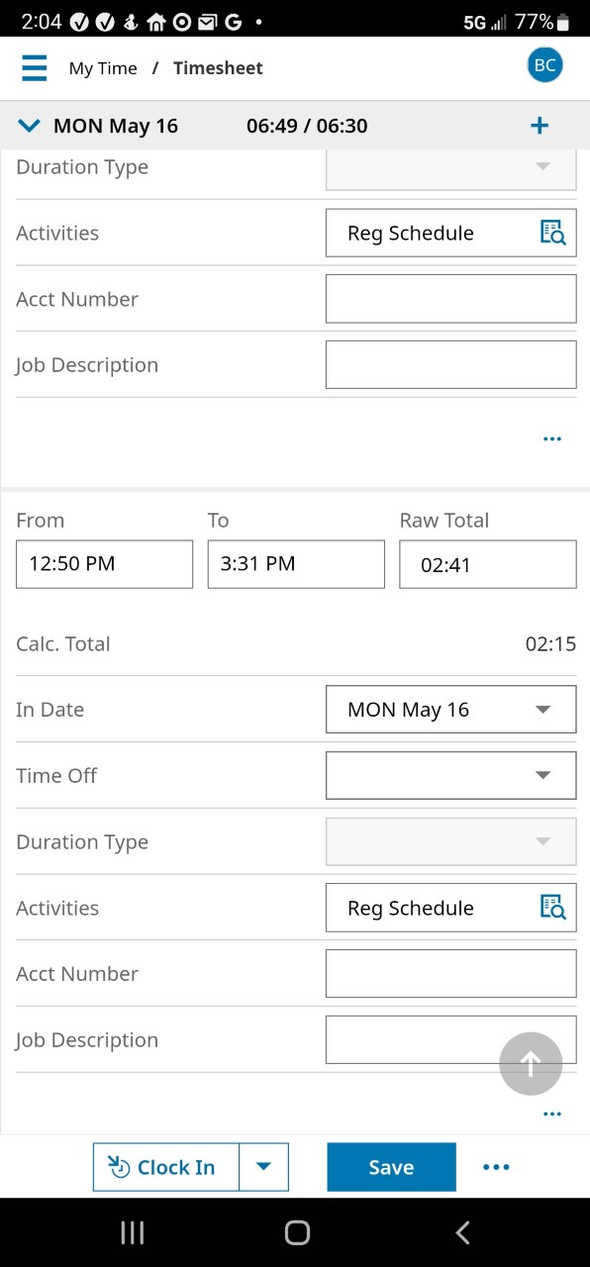

Additional time, if applicable, needs to be indicated as such and your activity may differ depending on your specific approval (eg: 6th period stipend, beeper, banquet time, etc). Click on the search box for a list of your approved activities.

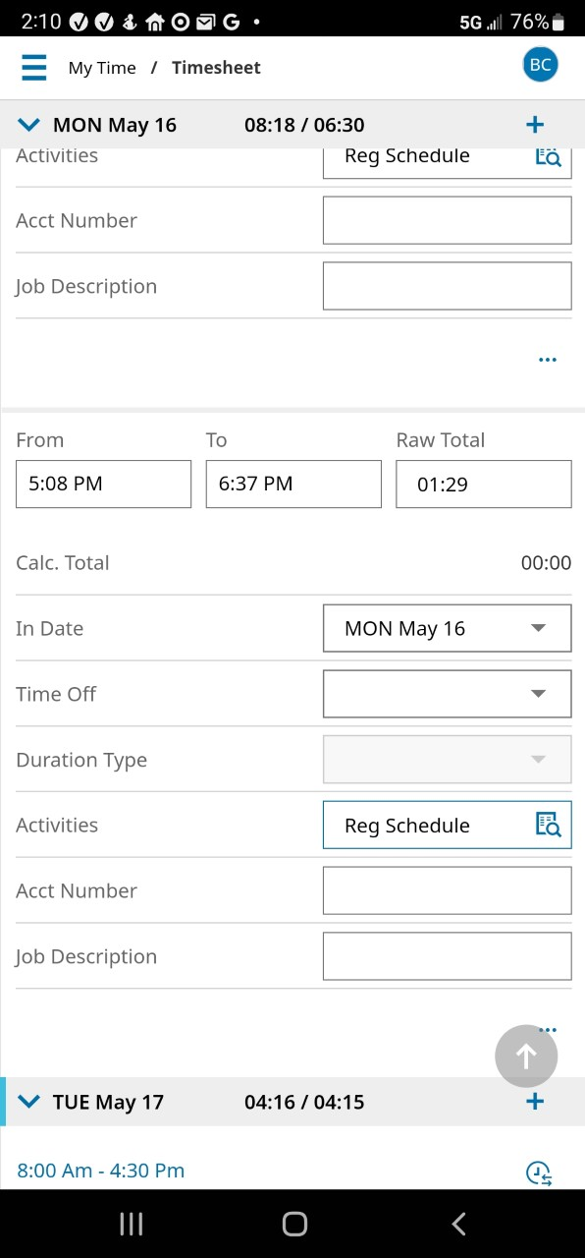

A list of your approved activities opens. “Voucher” is a generic term and should not be used for specific Board approved time such as 6th period, stipends, or co-curricular time. Select the appropriate activity.

If you do not see your activity in your approved list, please contact [payroll@wtps.org](mailto:payroll@wtps.org) for assistance.

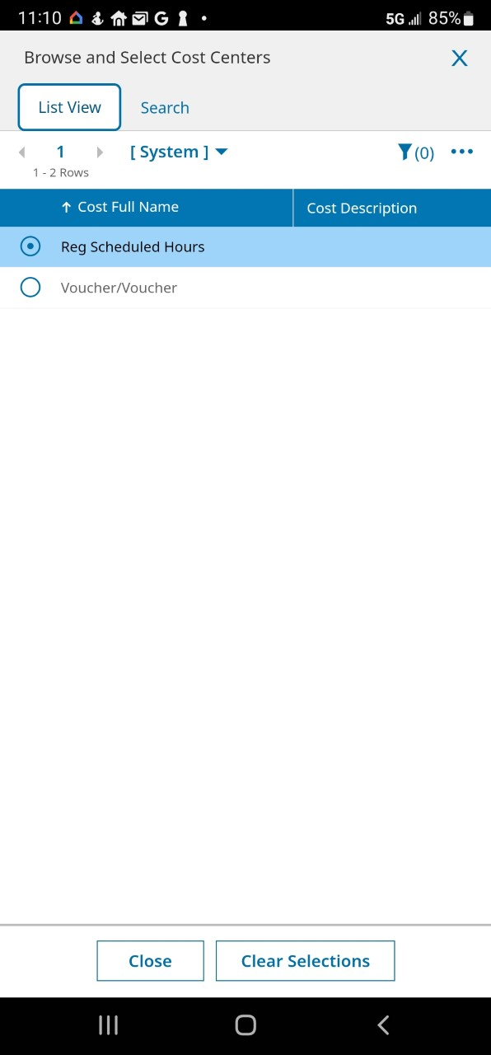

All additional time **MUST** include an account number (if known) and job description. If you do not know your account number, your supervisor should enter it for you. Your description should be as detailed as possible. Some examples of your description might be:

Subbed for John Smith

Academic Recovery

Class Coverage for 4th Pd Chemistry

Math Club

Student #123456 (for Homebound)

10th grade Algebra II (for 6th period stipend)

Timesheets submitted to Payroll without account numbers and job descriptions for additional time will be rejected.

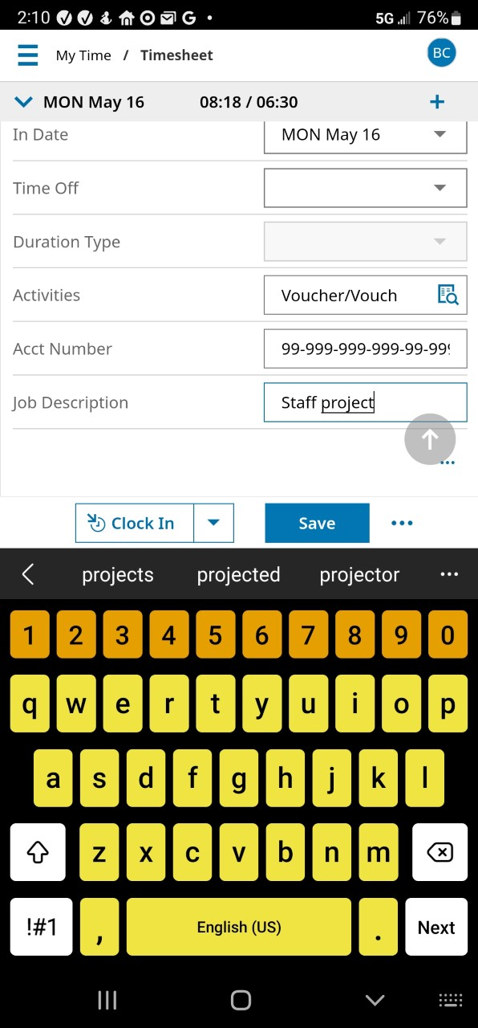

Once you’ve entered the required information, click Save.



You’ll get a confirmation.

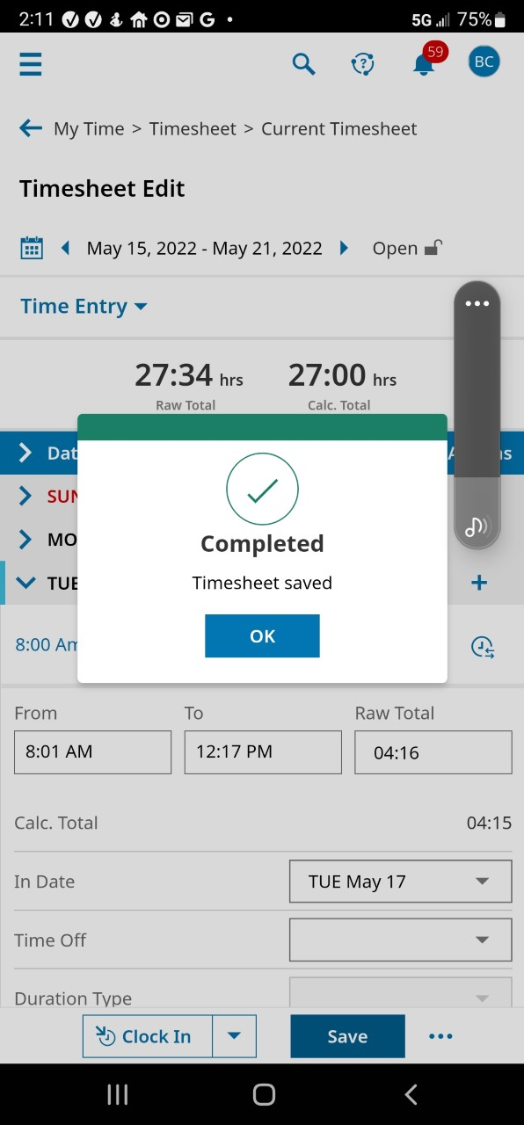

As you review your timesheet, you might find that you missed clocking in or out at some point during the week. You must request to have that missing time/day entered. In this example, the employee forgot to clock in on Thursday, May 19th. Click on the carat to expand the date.

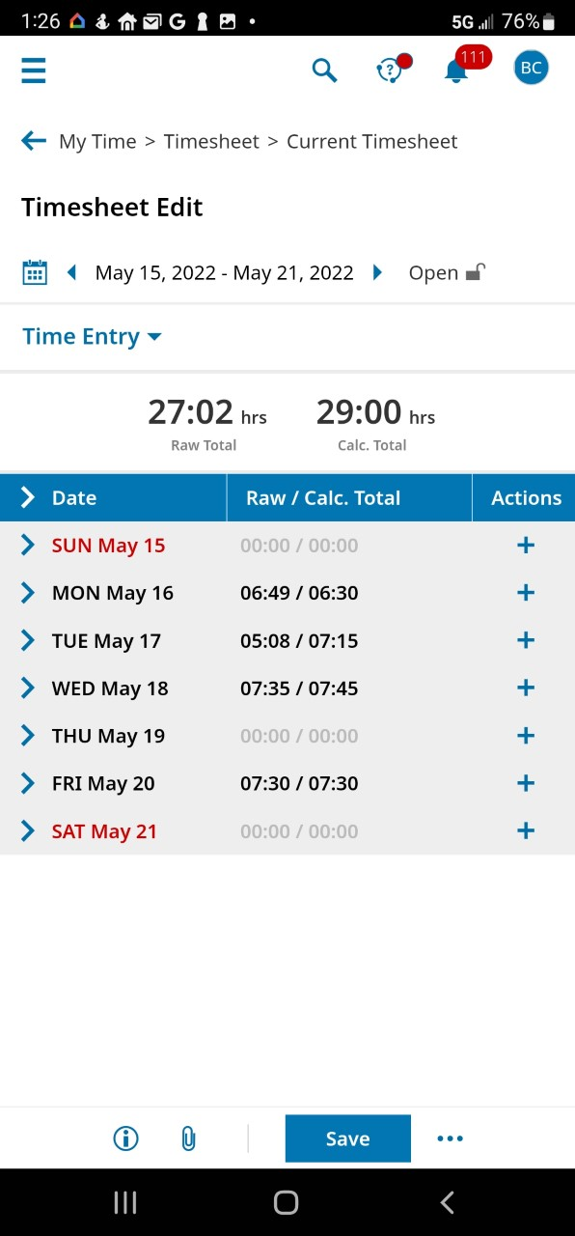

Click on the three elliptical dots.

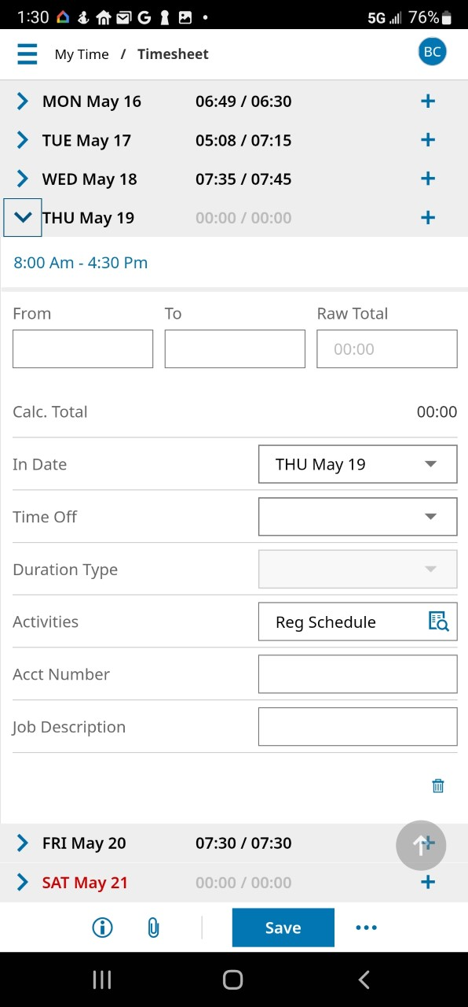

Click on Change Request.

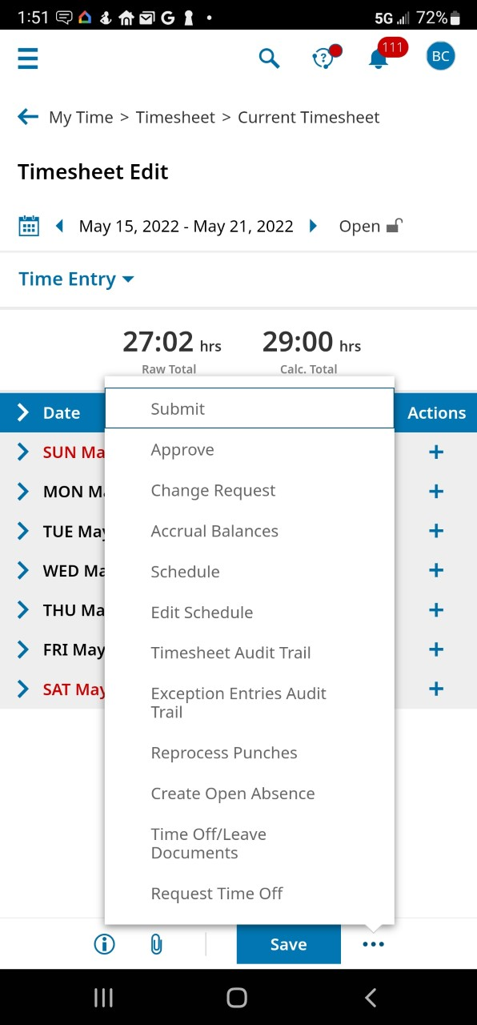

Click on the drop-down arrow to open the selection box

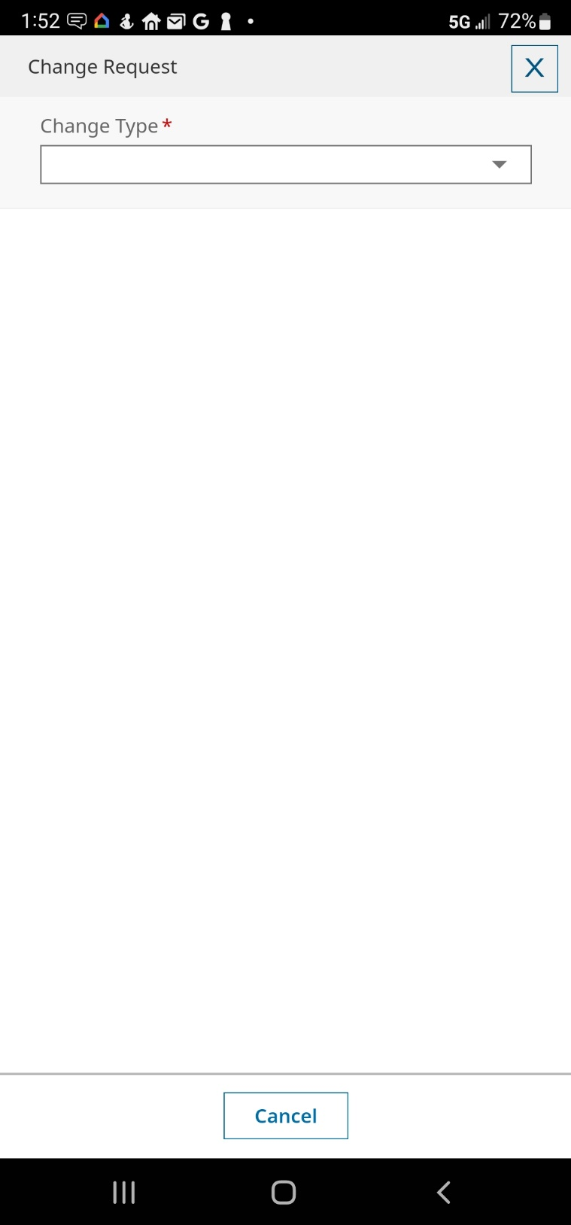

You can see that there are multiple options which will enable you to correct your timesheet for proper payroll calculation. Please note that you can only submit one change/correction per request. In this example, the employee forgot to clock in and out. The first request will be to clock in for the missing day, so we’re going to select Add Punch In.

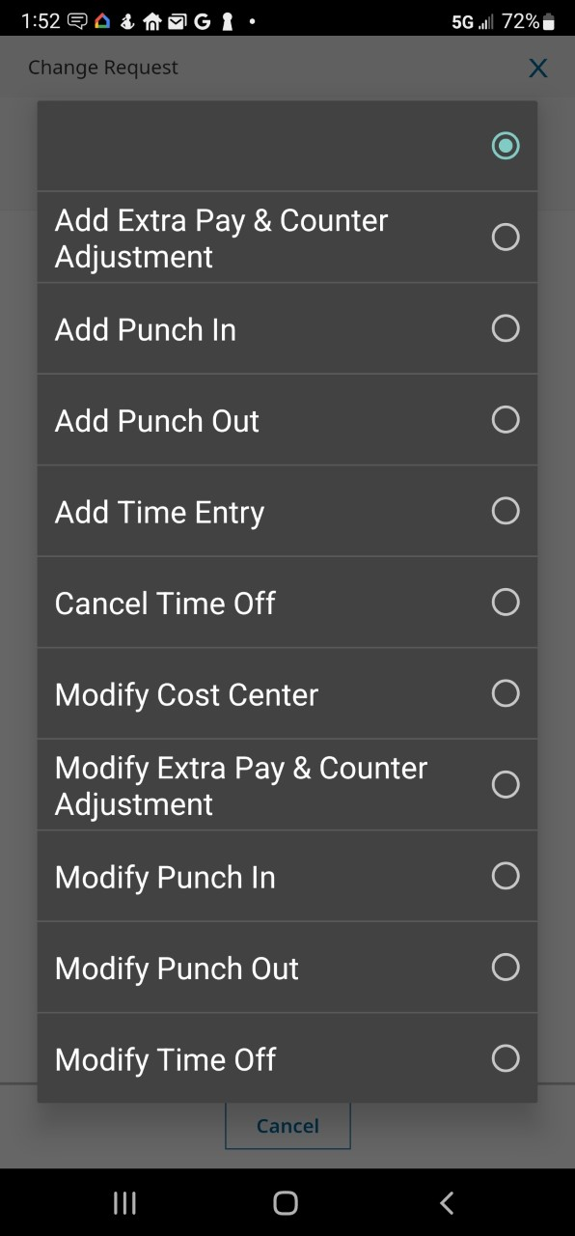

Next, confirm that the date is correct and then click on the clock icon.

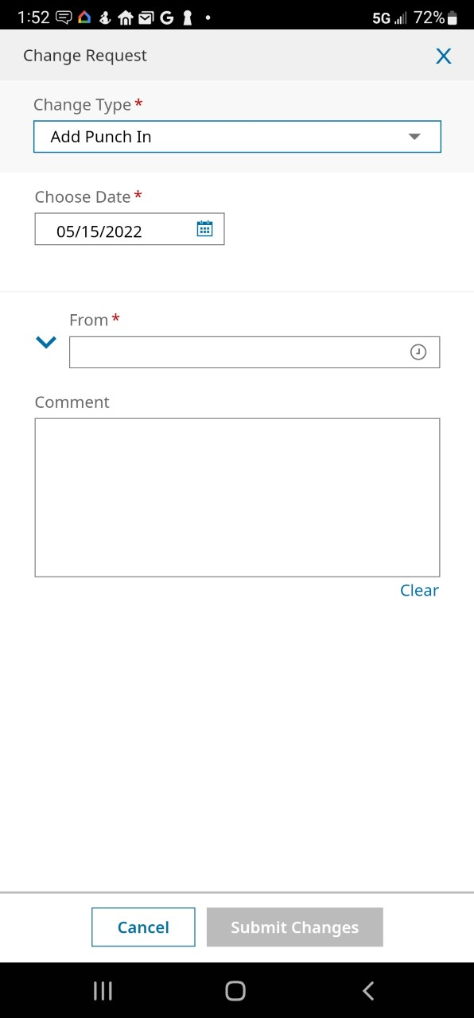

A clock opens and the hour is highlighted. Drag the hand to the appropriate starting hour. Once you release your finger, it will default to the minutes. Simply click on them to toggle back and forth if need be. Then click on AM or PM as appropriate.

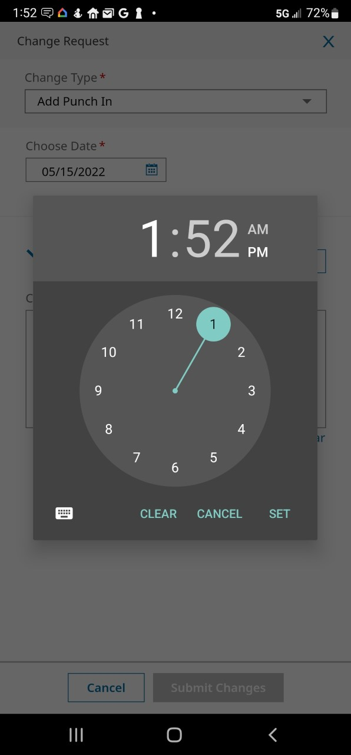

When the time is set correctly, click on Set.

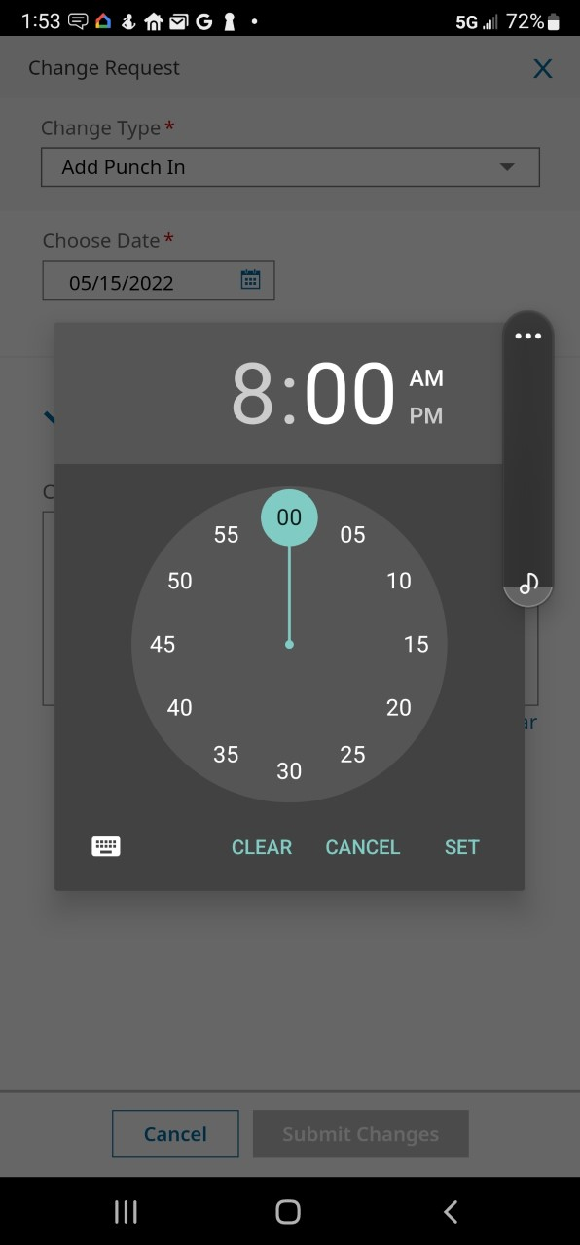

Next, you need to include a comment regarding the need for the correction. In this example, the employee forgot to clock in that day. Your comment should be as detailed as possible depending on the circumstances.

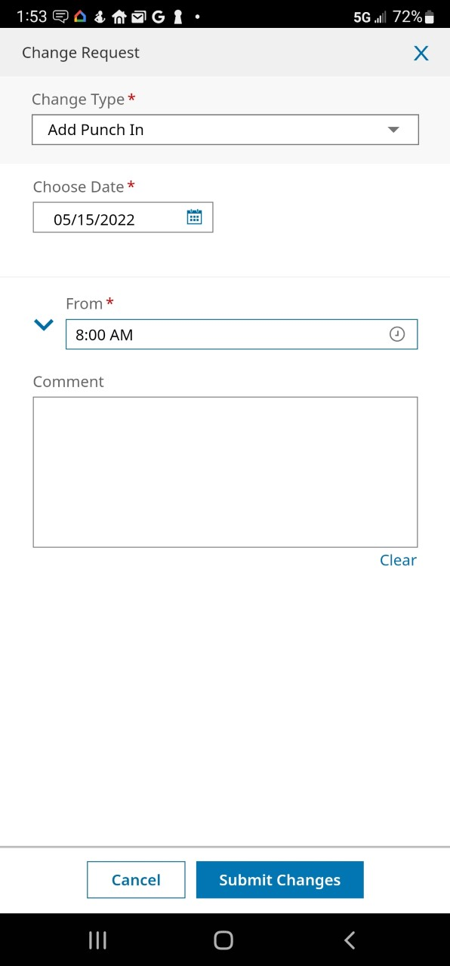

Review your request and if correct, click on the Submit Changes button.

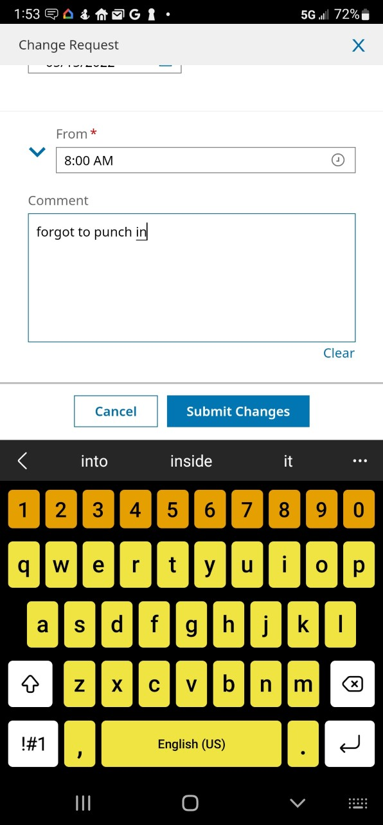

You will get a confirmation that your request was submitted to your supervisor. Click OK.

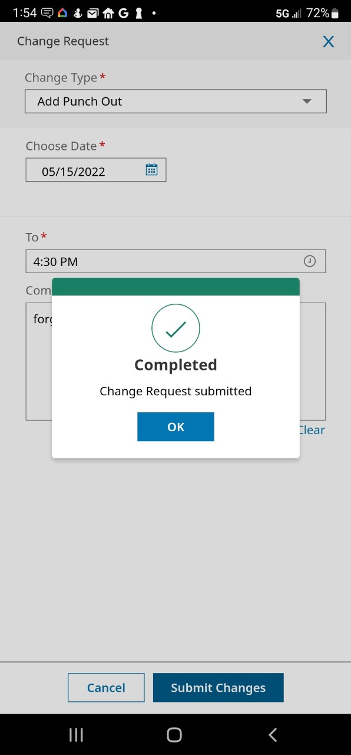

Repeat the process to request the missing punch out for that day.

The request(s) are submitted to your supervisor. Once he/she has had time to process your request, you will receive an email advising whether your request was approved or denied along with a comment/reason for the decision. If approved, the correction will be made in your timesheet.

Your timesheet is now correct and you are ready to submit it for approval. Click on the three elliptical dots.

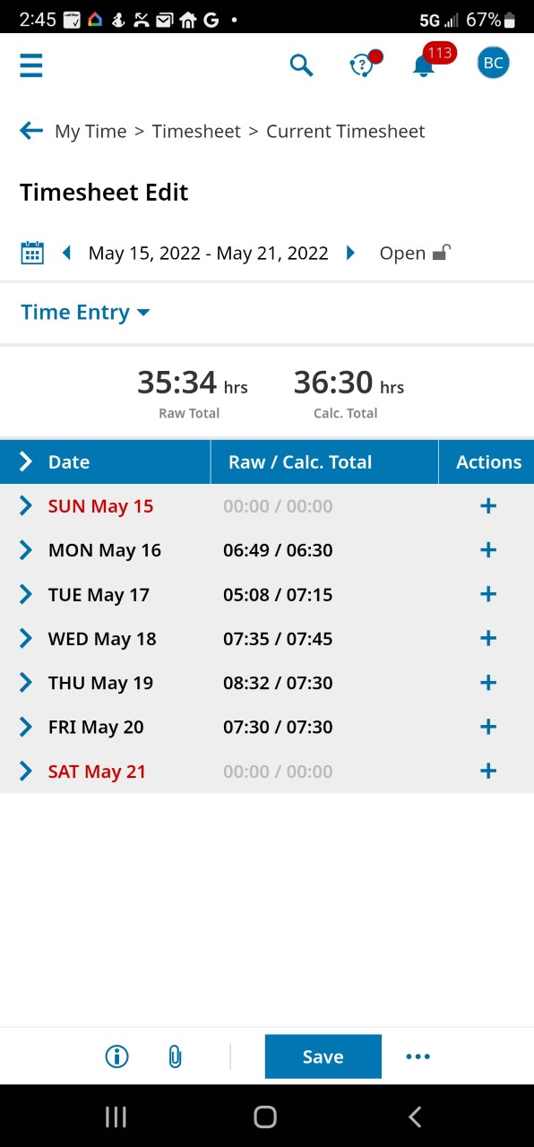

Click on Submit

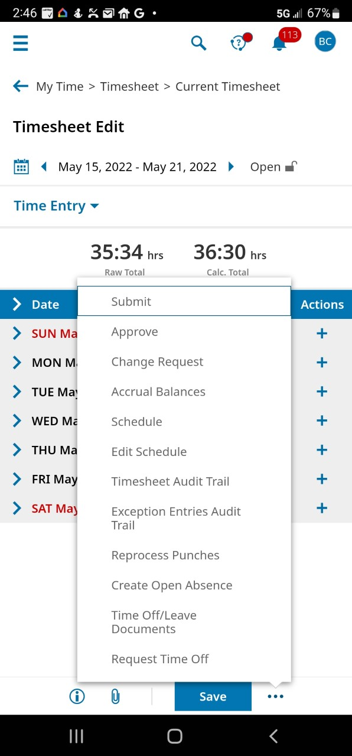

You can choose to leave a Comment if desired, otherwise click on the Submit button

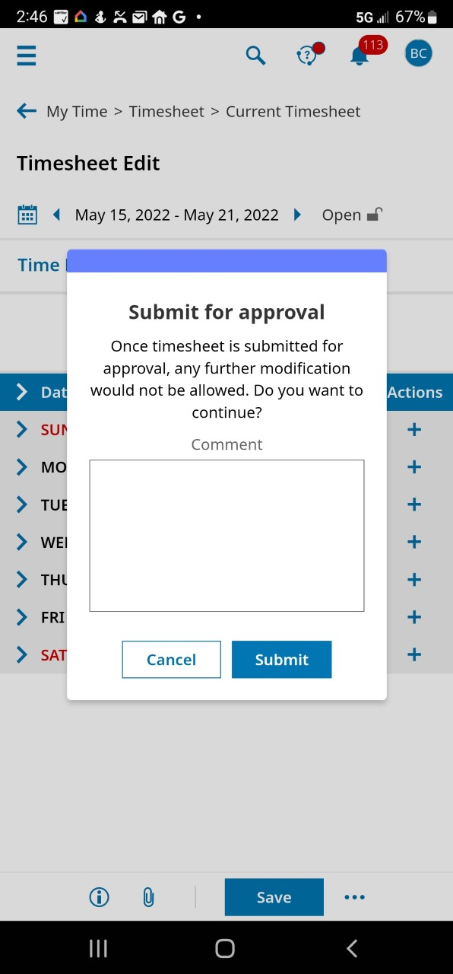

Congratulations! Your timesheet has been submitted to your supervisor for approval. Click on the OK button.

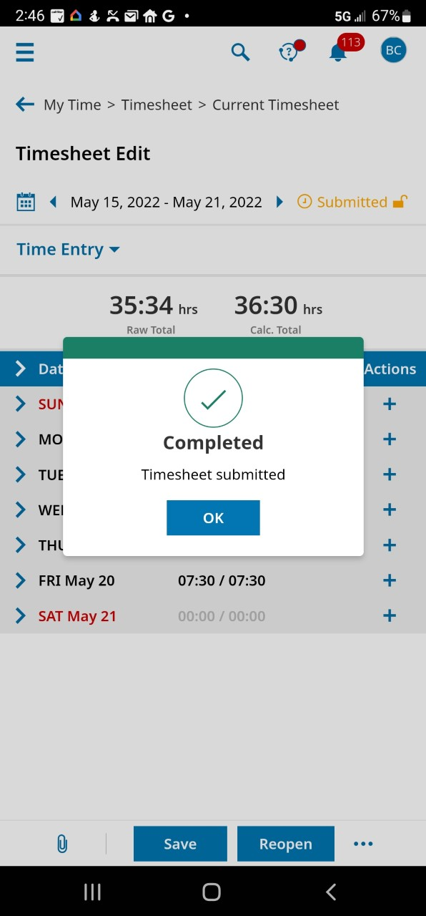

The timesheet now reflects a Submitted status and you can log out of the app.

